CREATING LINKS:

IMPORTANT TAGS:

<a>for links and set href and title inside it.

name: it is use to name the link when we don’t initialize it separate as a section or para.

href:use to give reference link which we want to open

title: give title to link.

Target:use to open link in new tab.

SIMPLE LINK: internal link

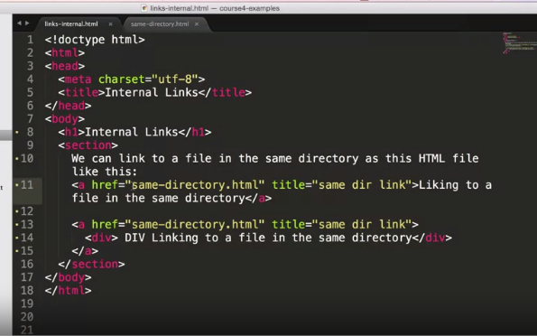

Links pretty much what makes the web what it is. In this lecture, we're going to take a look at different types of links and how you could create them in your HTML page. So the first type of links that we're going to take a look at are internal links. Here I am looking at the file called links-internal.html, and it's located in the examples/Lecture09 folder. And here we have a couple of links we're going to take a look at. Now the way you create links is by specifying an a element with an attribute href. And href stands for hypertext reference. The value of href can either be a relative or an absolute URL. In our case here, since we're discussing internal links which are links that point to internal web pages of the where application, the links we're showing are all relative URL links.However we could still have an even absolute URL links as long as they point, again, to the same web application that we're in. Since we're providing no directory information, the browser will assume that same-directory.html is a file that lives in the same directory as links-internal.html. It's also a very good idea to always specify a title attribute for the a tag. The title attribute is used by the screen readers that help the visually impaired people get through the web page. The content in between the opening and closing a tags is the content you're going to see in the web page, when it is served and on which you're going to be able to click to go to the href that the a tag is configured with. Note the second example of our a tag. In this example, we're surrounding a div tag with our anchor tag. In other words, this div tag is going to be the content over our link on which were going to be able to click.

OUTPUT:

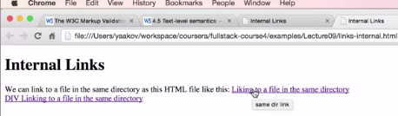

TO OPEN WEB IN NEW BROWSER:EXTERNAL LINK

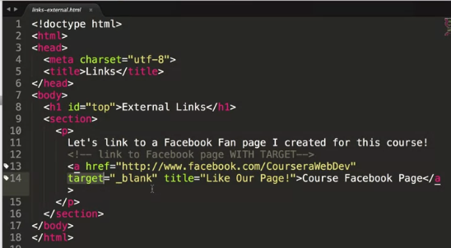

look at an example of an external link. Here we are in Sublime Text again and looking at the file called links-external.html which is again located in the examples.

And this document basically contains just a single link. There's really nothing super special about external links other that their href value usually starts with http:// because it's usually the case that external links are hosted on a different domain name than your website. However, there's one feature of the a element that I would like to demonstrate that is quite often used in conjunction with external links. And that is the target attribute. Target attribute, when it's set to the value _blank, forces the browser to open this page in a new tab or a new window. The reason that's advantageous is because nowadays unfortunately people have a very short attention span, and if you take them from your website to a different website, it is a very good chance that they will never come back to your site. And usually you don't want them to leave your site completely. So target="_blank" is very useful in that regard. Let's a take a look at this page in the browser.

Play video starting at :5:23 and follow transcript5:23

And here's the page in the browser. And if we click this link, Coursera Facebook Page, it will open a new tab and will load the Facebook page pointed to by that link

SECTION REFERENCE IN LINK:

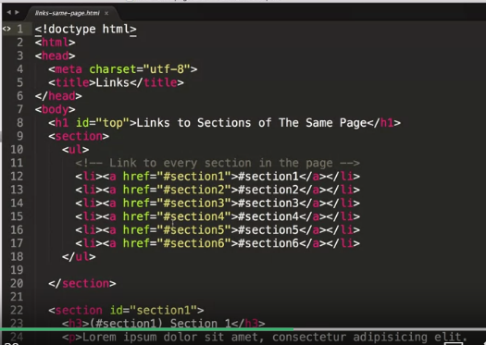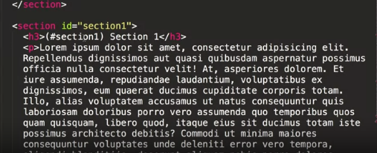

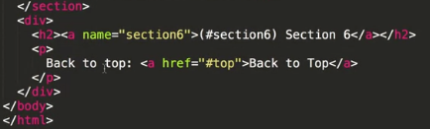

Another type of link that is extremely important to know about is a fragment identifier. So here I'm in again in Sublime Text in links-same-page.html. That is located in examples/Lecture09 folder. And as you could see, the links that have set up here all have a very specific format in the href attribute. It's a # followed by some name like section1, section2, and so on. Now what these links are pointing to is a section of our page. Now you could identify a section a couple of different ways. You can have in any tag that has an id with that section name. Notice that the section name does not contain the # sign. Only the link to that section contains the # sign. That's one way to identify a section within the page. Another way is, if we scroll down all the way to the bottom of the page, is to create an anchor tag with a name attribute and name the section very similarly to the way you name a section id. The way you refer to these sections is exactly the same, you put a # in front of the name of the section and stick that value in the href attribute of an anchor tag. So let's take a look at this document in the browser. And here's the document. As you can see, we have six different links. And if we click on any one of these links, it will take us to the section of the page that is marked with that particular id.

Play video starting at :7:28 and follow transcript7:28

If we scroll all the way down, we even have a back to the top link which basically points to all the way to the top. Now, the top is right here, and if you look at the code and scroll all the way up, we have an h1 tag that has an id with top which allows us to scroll all the way to the bottom of the page, see that link, and jump right back to the top.

Play video starting at :7:53 and follow transcript7:53

What's really neat about fragment identifiers is if you click on one and you have them in URL, you could copy and paste this URL and send it to a friend as a bookmark. And when they paste it into their browser, they will be taken to this page and jump straight to the section that was pointed to by the fragment identifier. Now I am on my local hard drive, and I'm not on a server so obviously sending this link that points to my local hard drive is not going to do any good. But if we're on a server, this link with the section identifier would have taken anybody anywhere, with a connection to the internet, to the proper page and to the proper section of that page. While fragment identifiers are very useful in order to jump to different parts of the same page, recently they have become even more important as they're used for navigation within the SPA or Single Page Applications. And SPA, Single Page Applications have become extremely popular. So knowing how fragment identifiers work is an important step towards being able to code single page applications.

DISPLAYING IMAGE:

IMPORTANT POINTS:

<img>

scr:

alt:

&lt; :to represent lower than< with semicoloun;

&quot:to represent quotation “”

&copy:to copyright sign

**BASIC OF CSS**

Anatomy of css rules:-

There are so many css rules some of them are given below.

1. 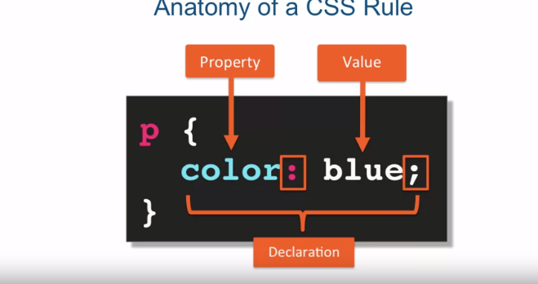First we discuss about selectors here the word (p) is the selector with open and close parenthesis inside it we have three parts.

*PROPERTY: property are predefine by css specification this is which is given by css and have its own values. It separate by (:) and terminate by (;) and semicolon not required.

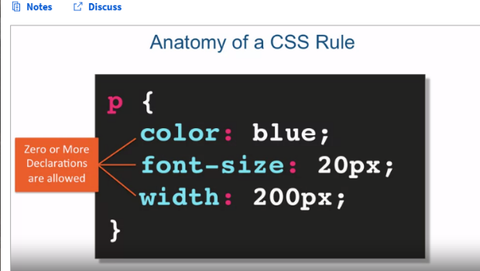2) more than one declarations allowed like changing size width etc.

3) 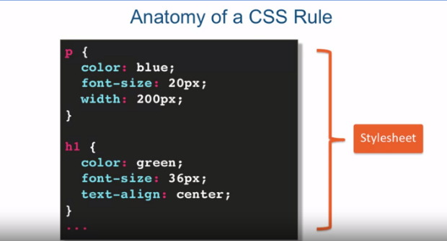You can style your headings too.

Example of above things :-

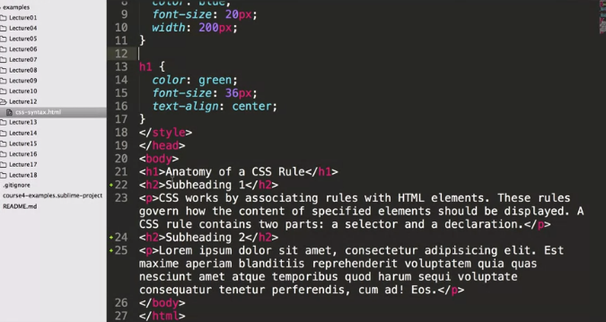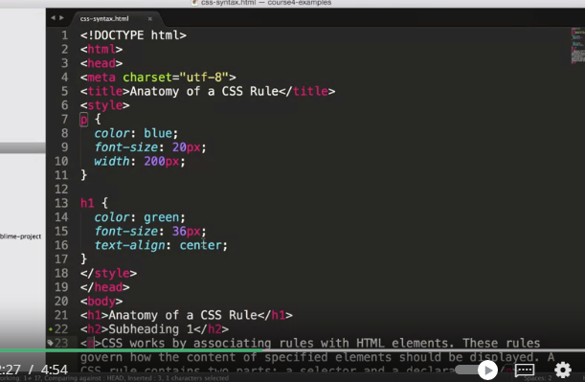

OUTPUT:-

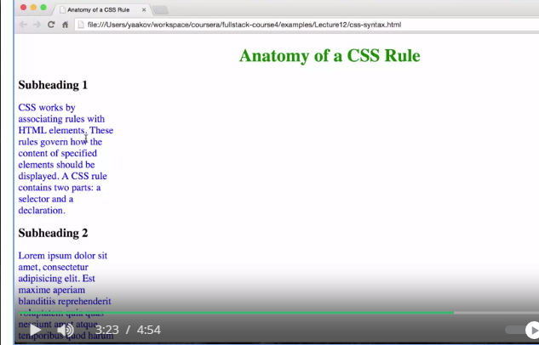

CSS selectors are used to determine which HTML element, or set of elements, to apply the CSS declarations to. The browser uses its selector API to traverse the DOM or Document Object Model, and pick out the elements matching the selector. Now crafting a selector is a great skill to have and not only for styling using CSS. That's because a lot of JavaScript libraries out there use the browser selector API to attach behavior and data to HTML elements. Much in the same way that CSS applies style to those elements. In this lecture, we're going to talk about three different types of selectors, element, class, and id selector.

TYPES OF SELECTOR:

1. ELEMENT:-

First element selector,

the element selector is just you specifying the element name.

For example, in this case, p for

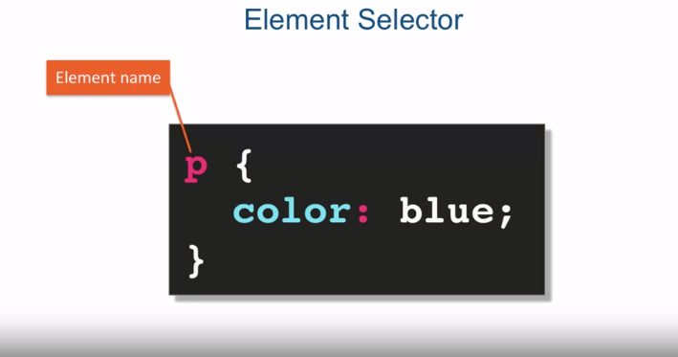paragraph says that every paragraph in our HTML document should be colored blue.

Play video starting at :1:2 and follow transcript1:02

As an example, if we specified p paragraph and color blue, that means

every paragraph in the HTML document will have its content's text be blue.

Obviously, this really doesFirst element selector, the element selector is just you specifying the element name. For example, in this case, p for paragraph says that every paragraph in our HTML document should be colored blue.

As an example, if we specified p paragraph and color blue, that means every paragraph in the HTML document will have its content's text be blue. Obviously, this really doesn't affect any other elements that contain text in them. For example, we can have a div element that contains text but that text will not be affected by our CSS rule that specifies that the paragraph tag should have content text colored blue.n't affect any other elements that contain text in them.

For example, we can have a div element that contains text but

that text will not be affected by our CSS rule

that specifies that the paragraph tag should have content text colored blue.

2) CLASS SELECTOR:-

Class selector is represent by dot before initialization in the below example we create blue class.

Here (.blue) is a class name next thing is we declare class inside the open tag and there is no space between them and when we use (class) we do not need to put (.) dot with the color. Next is the class selector, and the class selector is specified with a dot and the name of the class. In this case again, we're creating a blue class, a blue CSS class ,that will color whatever it targets with the color blue. The class selector does require a little bit of a change to your HTML document in that each element that you want that class applied to has to have an attribute class equal to the class name. So in this case we have a p, the paragraph tag and div tag both have the attribute class="blue" and therefore, their content or their text content will be colored blue. Notice that a different paragraph that is not marked with attribute class="blue" is completely unaffected by this. Note the differences between the way you define a class and then the way you use the class. You define the class always with a dot in front of a name. There cannot be any space between the dot and the name of the class in case no space between the dot and the word blue. However, when you use the class, you don't use the dot in its name, you just use its name. So here we have the paragraph tag with class="blue" without the dot in front of it.

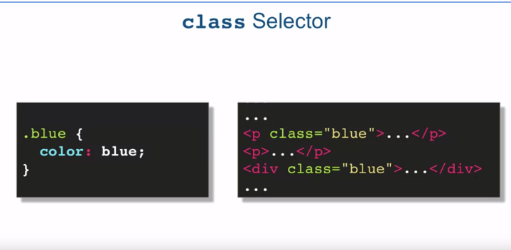

3) ID SELECTOR:-

e last type of selector we're going to take a look at in this lecture is the id selector. The way you specify an id selector is by specifying the value of an id of an element within your HTML document, preceded by a pound sign. So the name is a value of some id within our HTML document. So for example, if you have a div when id="name" and then you specify your CSS rule with a selector #name, the CSS declarations for that #name will apply to the content of the div element with its id value name. Note that obviously everything else in the HTML document is completely unaffected by this. Similarly, in the way you define a class selector versus use a class selector, the id selector is defined with a pound sign followed by the value of an id within your HTML document. And again, you can not have any space between the two. But when you use it the pound goes away, it's just the actual value of the id itself. Now in order to write more efficient rules, CSS allows us to group several selectors into one CSS rule. Here we have two selectors grouped together, div and the selected div for the div element, and a selector class blue grouped into one, since they both share the same CSS declaration. And you can see, in our HTML, the blue colored text will appear in the paragraph tag that has the attribute class="blue" and in any div tag in the HTML document.

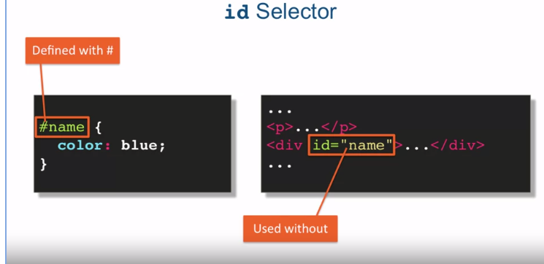

4) GROUP SELECTOR:-

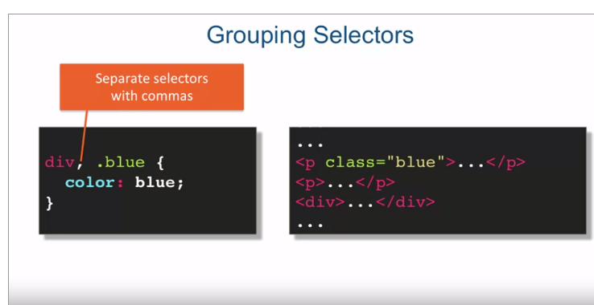Group selector are the combination of selector these selectors are separate by (,) commas.

EXAMPLE:

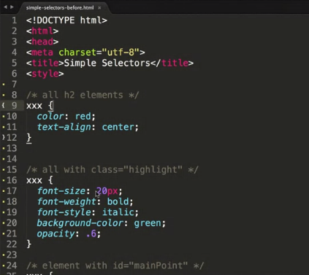 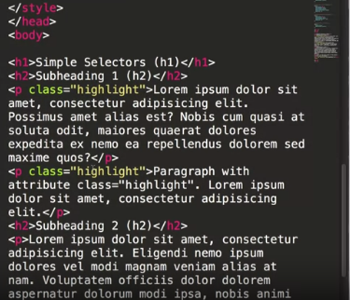

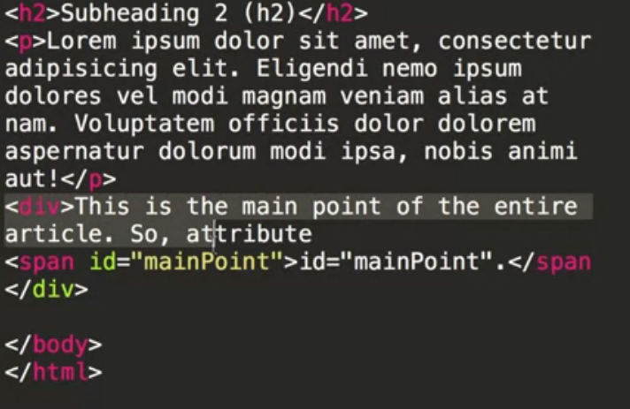

5) COMBINING SELECTOR:-

In this selector we can assign something particular such as if we want make the size of all the para whose class name is big than this particular para font increase.

Here 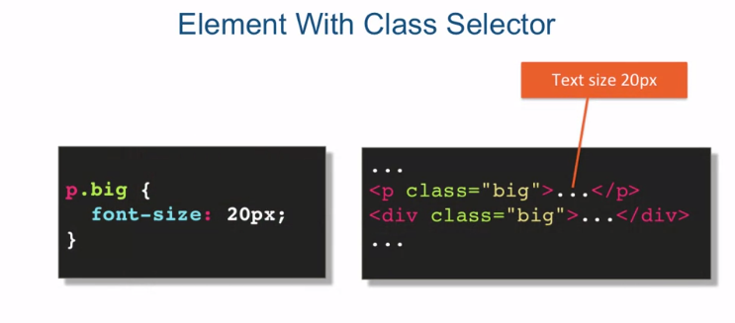(<div class=”big”>..</div>) is unaffected.

6) CHILD SELECTOR:-

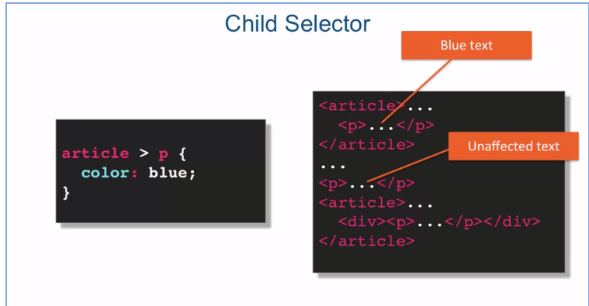As we know we have sub tags to here are the method to apply on selector on that.

7) DESCENDANT SELECTOR:-

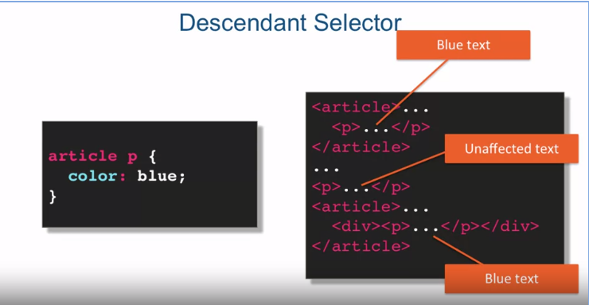

Another type of selector id is a descendant selector. And the syntax of it is, selector space another selector. And just like before you read it from right to left. So in this case what we're trying to do is target every P element that is inside at any level. Of an article element, which means that even if it's not a direct child, even if it's deep down, as long as one of its parents in its ancestry is an article, this rule will apply.So for example. In this case, it is a direct child of an article, and the text will turn blue. In this case, it's going to be completely unaffected, because it's not inside of article element altogether. And in this case, it will still turn blue, that even though it's not a direct child or element, since we're using a descendant, selector combination. The P element is still technically inside the article even though it's not a direct child and will have its text turn blue. Now, I want to point out that these selector combinations aren't limited to element selectors even though that's what I've used in the examples.

Example 2 :

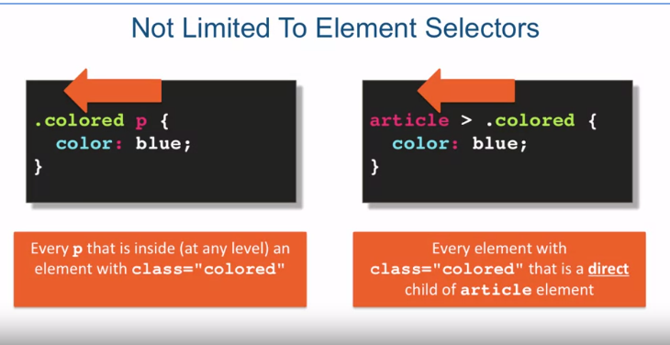

EXAMPLE BY CODING:

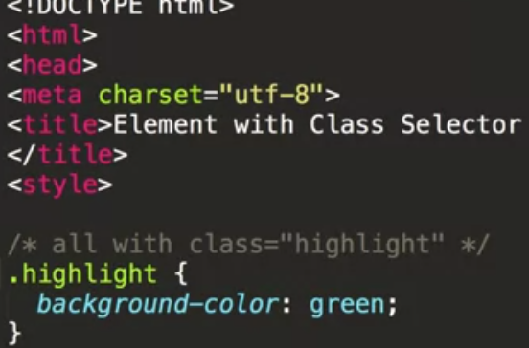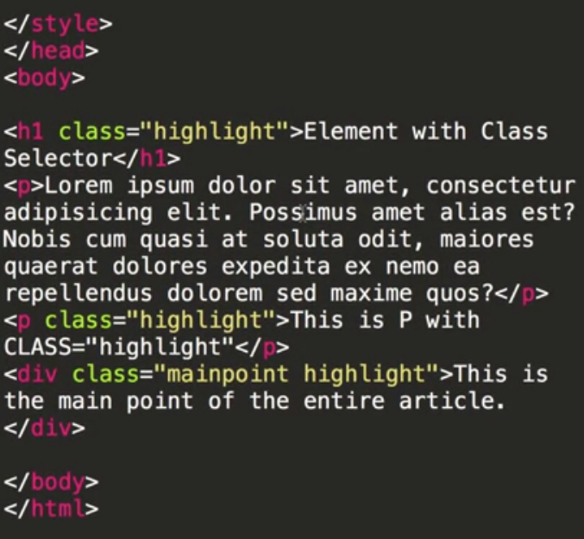3)

1)

OUTPUT:

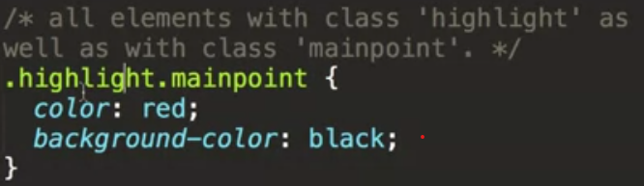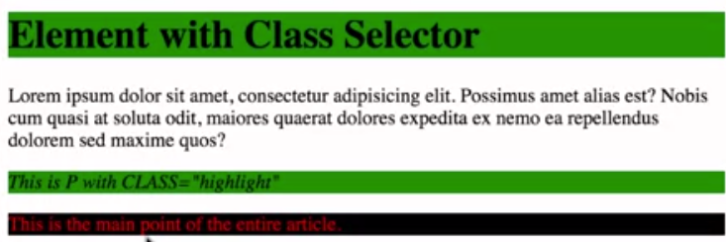

2)

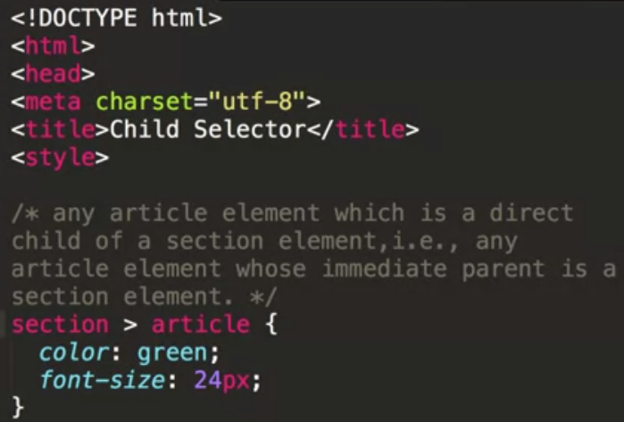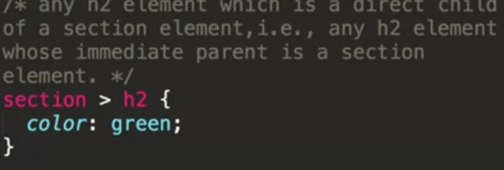EXAMPLE 2 CODE:

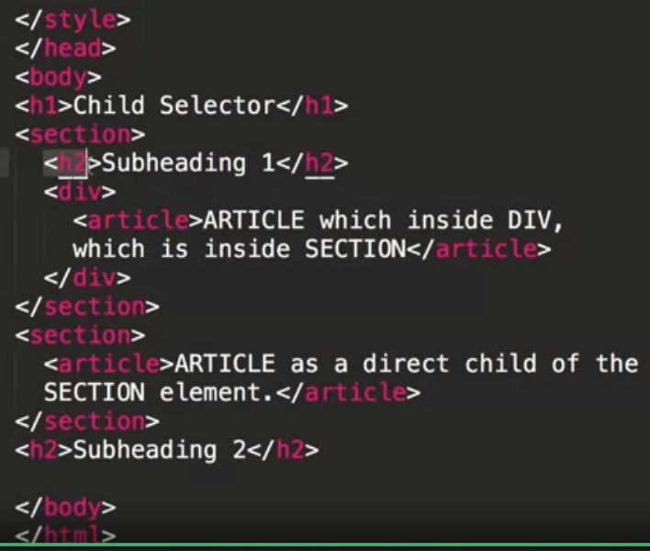

2)

1)

3)

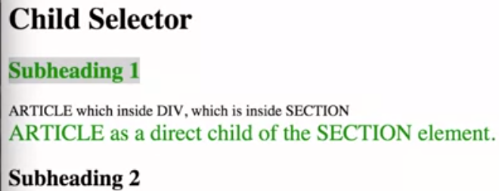OUTPUT

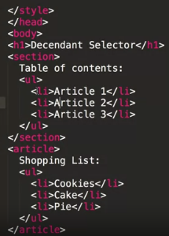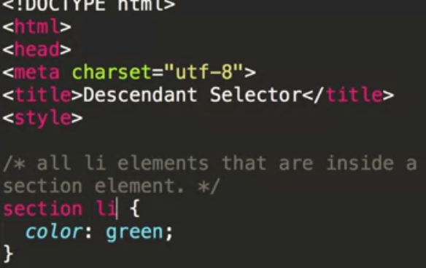EXAMPLE 3 CODE:

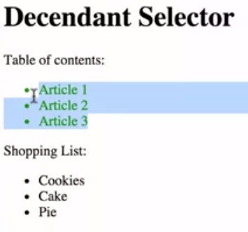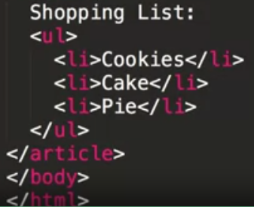

8) PSEUDO CLASS SELECTOR:-

Important things:

Hover:to chane colour at touch.

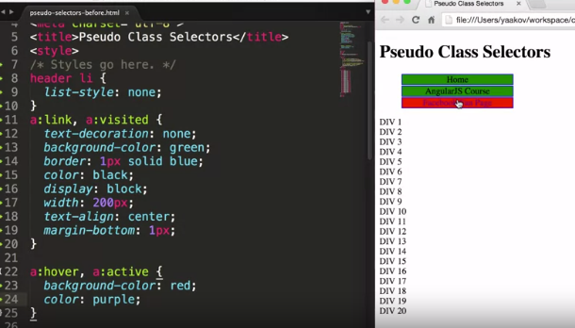

To make specific thing bigger:

Write its position .

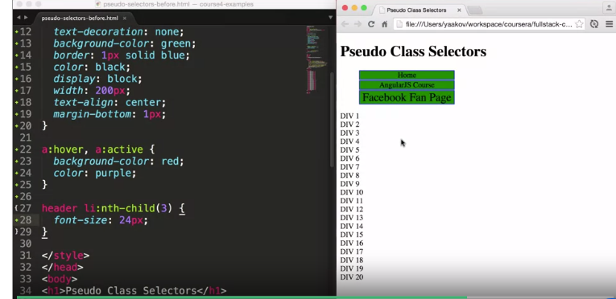

Hover on links :

Last style.

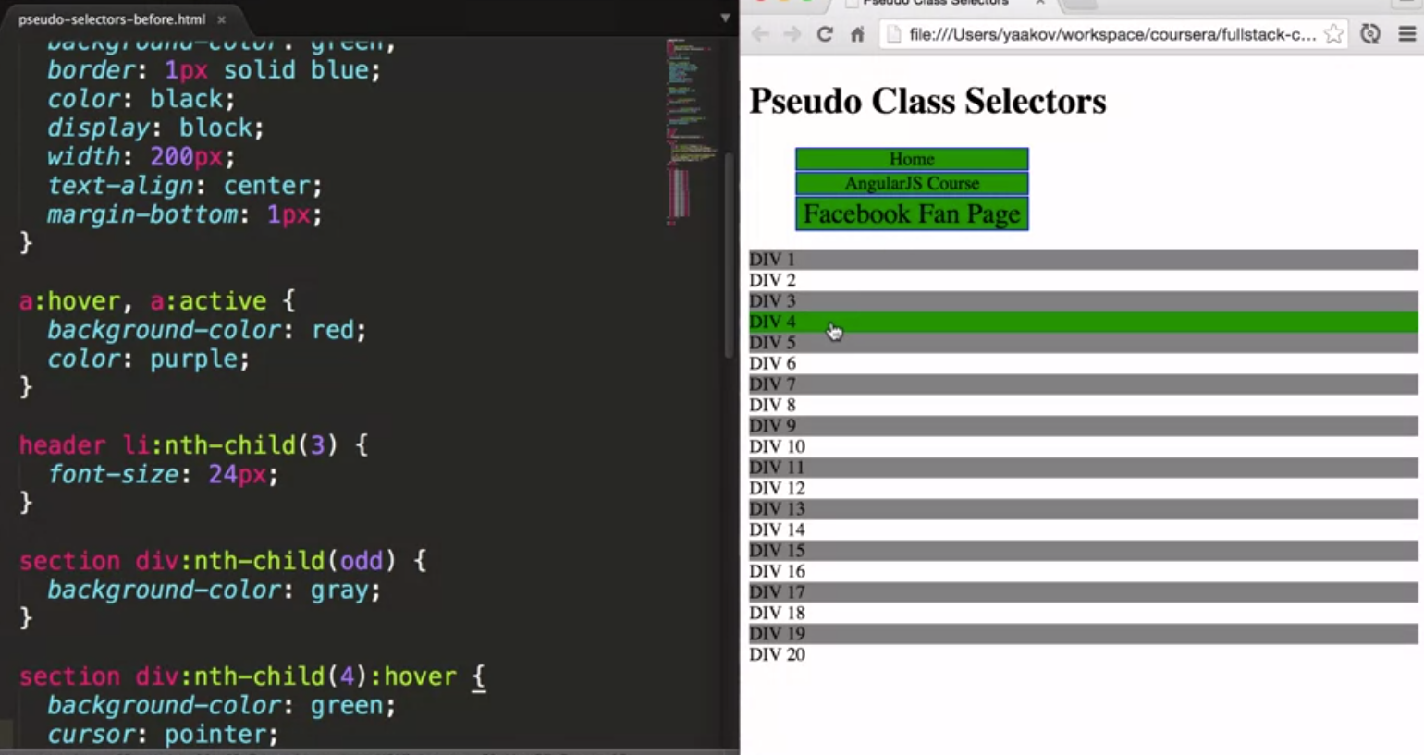

Style placement:-

This is how you use style tag all the selector are in style tag that are internal style.

1)inline style :-

Style that are inside the tag in which we want to perform style is called inline style.

Input: Output:

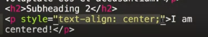 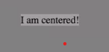

Now external style means styling by making different css folder and give the reference of that folder to the folder we want to style.

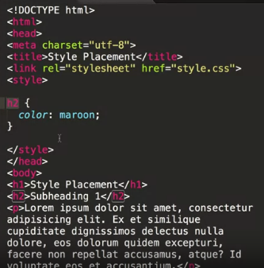in this we see link tag we give the reference of

Cascading:-

Cascading is a fundamental feature of CSS. It's an algorithm defining how to combine properties values originating from different sources. As the name itself suggests, cascading style sheets, in other words the cascade algorithm, is at the core of understanding and using CSS. The cascade combine the importance, origin, specificity and source order of the applicable style declarations to determine exactly which declaration should be applied to any given element. And if there's a conflict, how to resolve that conflict. In other words, how to tell which CSS rule wins. There are a lot of terminology and concepts surrounding the cascading algorithm. However, I believe to have a working knowledge of the cascading algorithm.

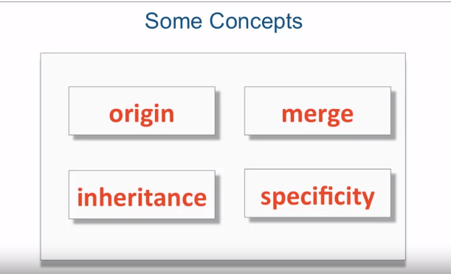

ORIGIN AND MERGE :-

When two declarations are in conflict, in other words they specify the same property for the same target, origin precedence rule kicks in, and it's a very simple rule. And the rule is, the last declaration wins. Now, when trying to figure out what the last declaration is, you have to remember that HTML is processed sequentially. That means top to bottom. So as you see the declarations happen, the lower on the page they are, the more precedence they have.

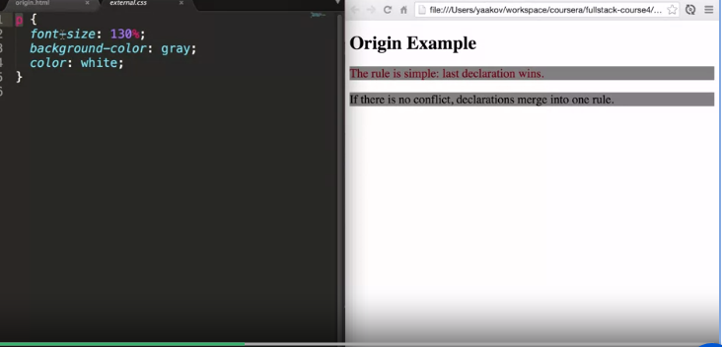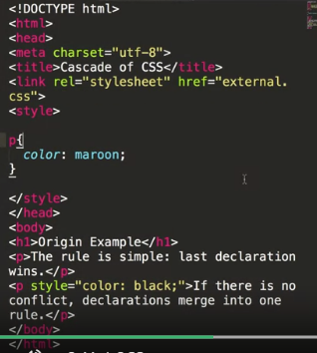EXTERNAL STYLE AND OUTPUT:

STYLING TEXT:

Font-family: It basically gives you commonly used font combinations. So what you usually put in the font-family is the value is combinations of fonts. And the reason you put not just one font, but a few fonts is because when you specify font-family in this way, you're relying on the client's computer, you're relying on the user's computer to have that font installed. And it's possible that a particular font will not be installed on the user's computer, so you want to provide some options, and at the very least, you want to provide whether you want a serif type of font, or sans-serif type of font.

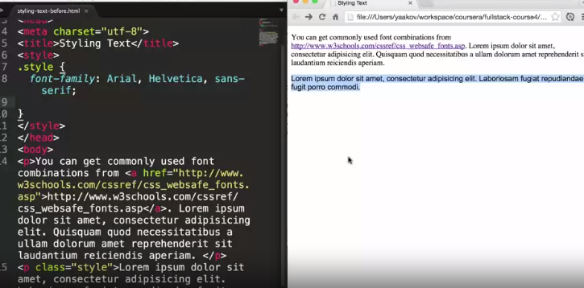

COLOUR:

To change colour.

Font-weight:

To make bold use font-weight.

Pixels are x3 time pore than em 3em=90px

Font-style:

font-style use to normal or italic show.

Text-transform:

text-transform shows how our text could show like capital , small, etc.

some extra:

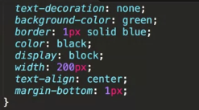

BOX MODEL:

CONTAIN PADDING ,BORDER AND MARGIN.

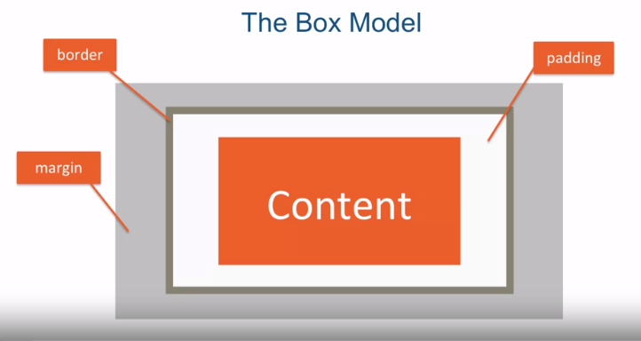

In order to remove space in bordering we need to write ( padding=0 and margin = 0; )

For padding:

Before:

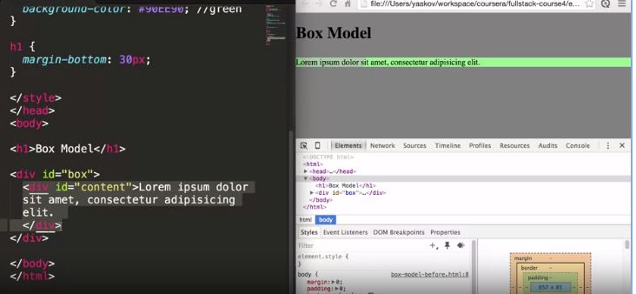

Now:

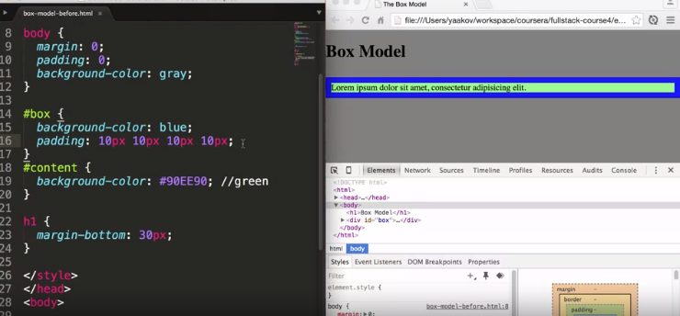

Because of padding in (#box) i.e top right left and bottom.

Now after further change:

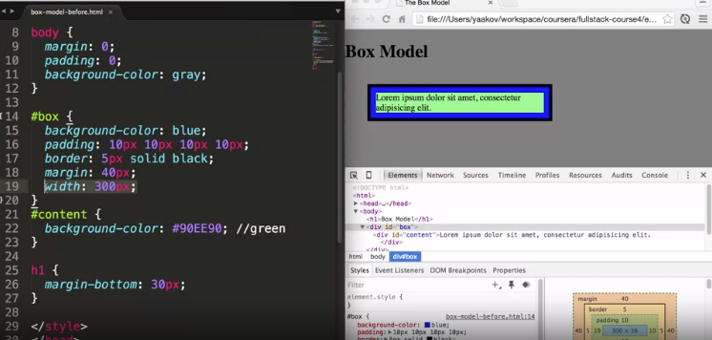

But use box-sizing :border box is good instead of these.

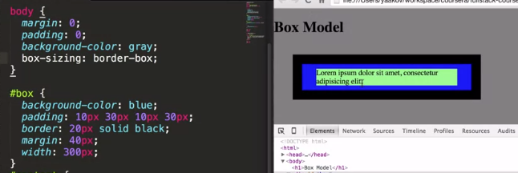

Star selector:

star selector says is, go ahead and select every element there is and apply these particular CSS properties to them. The difference between star and placing some property in a parent element for example is that star says I am not asking you to inherit anything, I am saying select every element. Which means it's as if it took this property and this value and then it went to the HTML and it applied it to every element it saw, it applied that particular property and value, which in this case is box-sizing: border-box. So that's how properties like box-sizing are applied across your entire page.

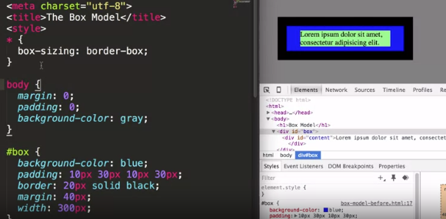

Cumulative margin:

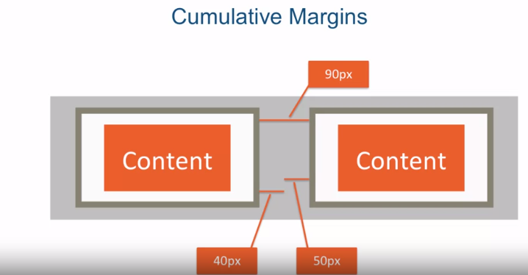

90px is cumulative margin. But if we have to element top of one another than the lager margin wins and called as margin collapse

OVERFLOW:

Use for overflow of the content to stop.

Before:

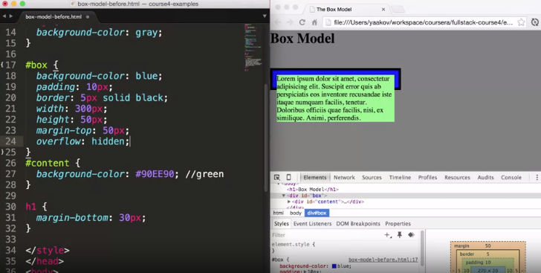

After:

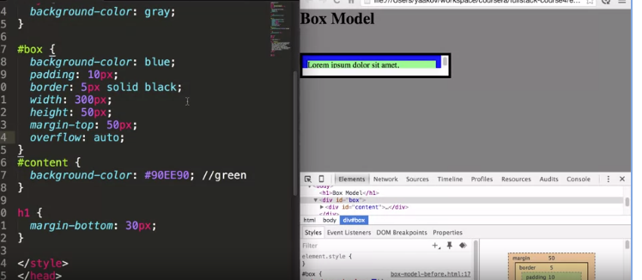

Now we can scroll to all content.

Pictures as background:

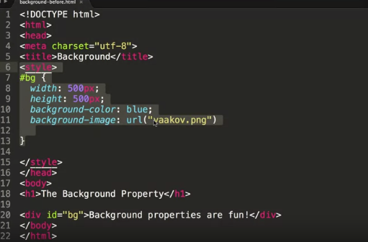

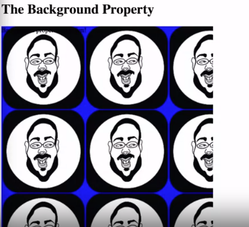this is only with bg because we put in bg id style want whole than put it in body.

Want no repeat of image :

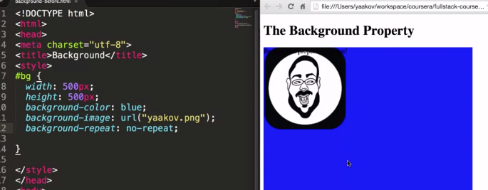

Background position:

need to give to value horizontal and vertical.

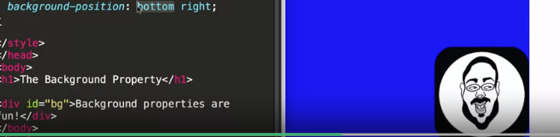

ALL IN ONE :

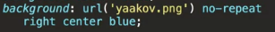

Positioning:

CLEAR: use to set element in margin

Before

Because of margin-right in p.

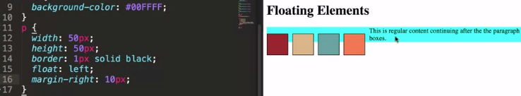

After:

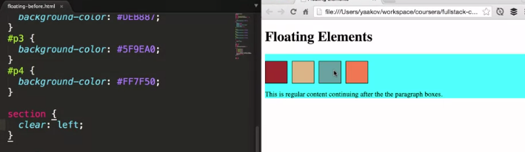

It means nothing is allowed to flow at left.

STATIC POSITIONING:

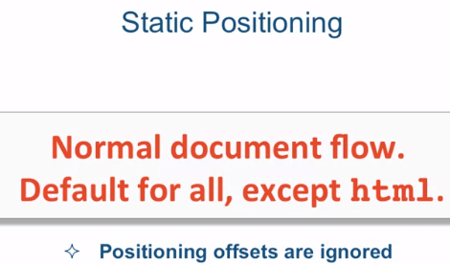

RELATIVE :

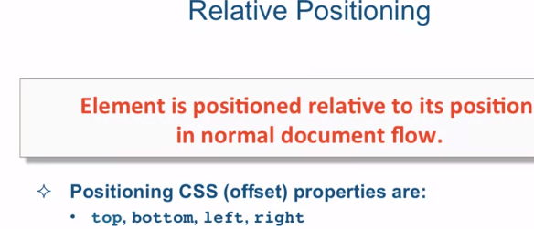

when you position element as relative you're basically creating like an anchor for the offsets. So the elements top, bottom, left, and right edges become the boundaries from which you offset the element. The important thing to know about relative position is that the element that is set to relative positioning is not taken out of normal document flow. In fact even if it's moved by using the offsets, its original spot is preserved. So as far as the rest of the HTML elements and the rest of the HTML page is concerned, that element is still sitting in its original spot eve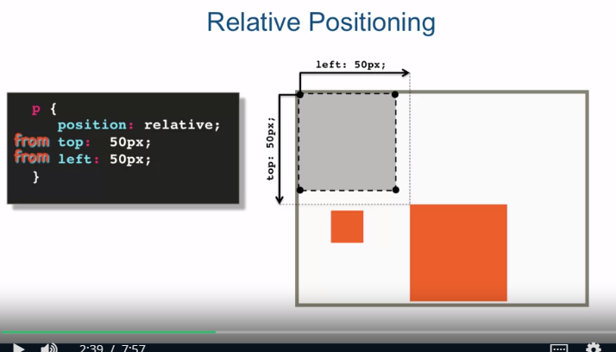n though visually its off somewhere else.

ABSOLUTE :

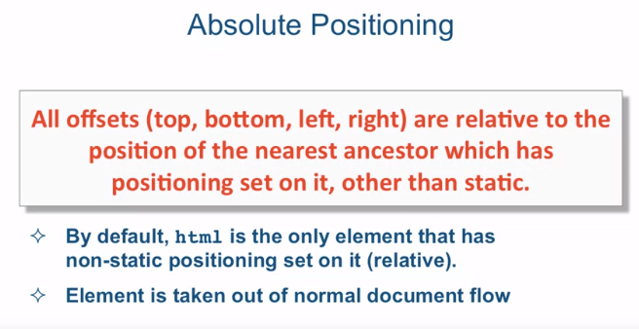

BEFORE:

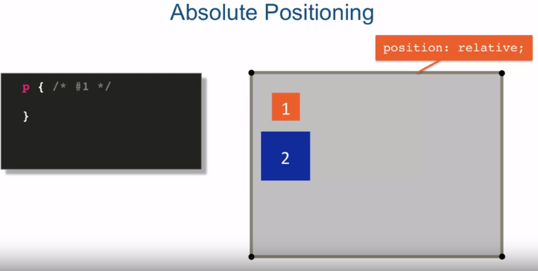

AFTER

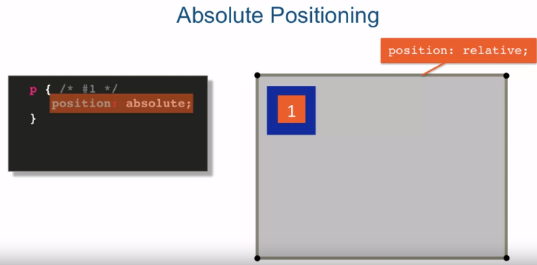

MEDIA QUERY:

Media queries allow you to group styles together and target them to devices based on some criteria. For example, you can target a device by its width, its height, or orientation like landscape or portrait. Of course one of the most obvious differences between viewing a website on a desktop browser and your cell phone is the screen size. Remember that using CSS you have the power to produce very different web page layouts from the same HTML. Remember CSSgarden dot com? So, it only makes sense then, that the most common way to adjust the styling and layout of your page is to provide different styles for different screen sizes of the user's devices. This is why it's crucial to learn at least the basics of how to utilize media queries. Without them responsive design, which we'll start talking about fairly soon, wouldn't be possible. Let's go ahead and explore the basic syntax of media queries. A media query starts with a keyword @media, and then it is followed by a media feature, and followed by curly braces. Within those curly braces you have your styles, it's basically like a style sheet within a style sheet. Each media feature resolves to either true or false. You can have more than one media features combine together using logical operators. If the media features resolve to true, the style within the curly braces apply. When writing media queries, make sure you close the curly braces for the media query as a whole and then separately each styling rule.

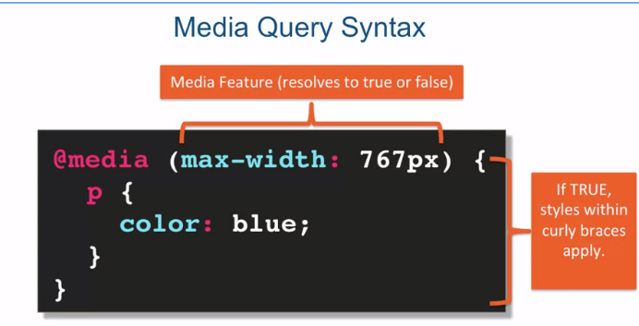

Different types of media.

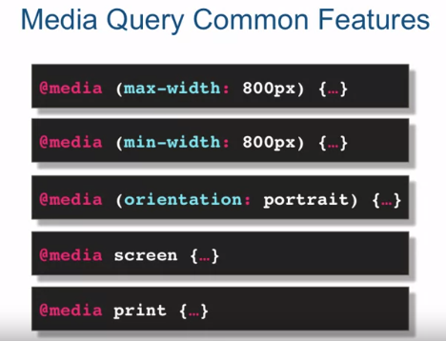

COMBINE :

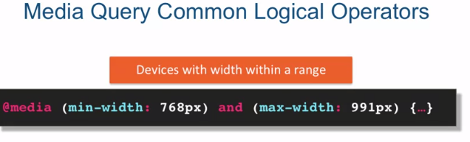

IMPORTANT LARGE AND MEDIUM DEVICE PIXEL:

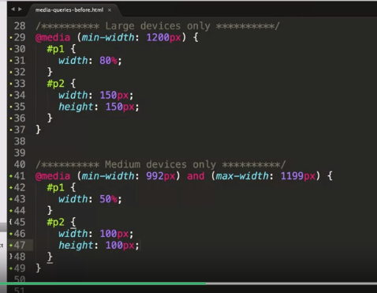

RESPONSIVE WEBSITE:

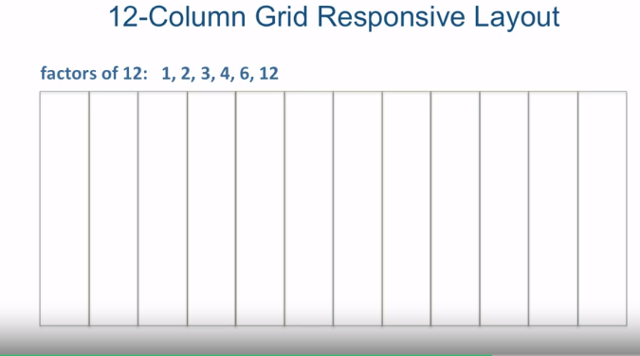  
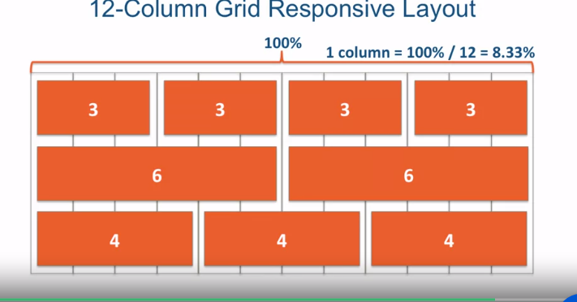

AND FOR 2 COLUMN 100%/12*2 AND SO ON.

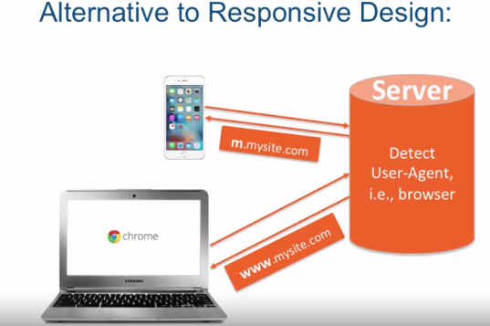

1. MOBIEL DEVICES.

It has further types

1. DESKTOP DEVICE.

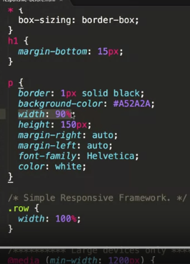

CODE FORM:

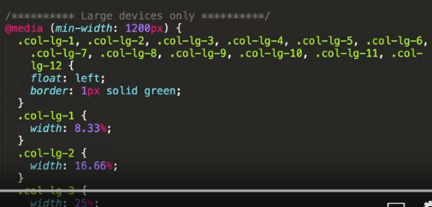

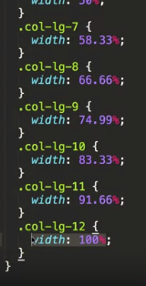

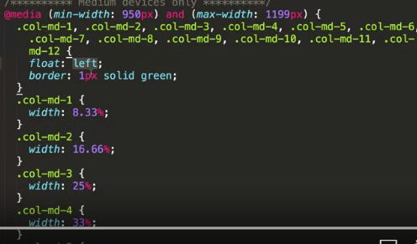

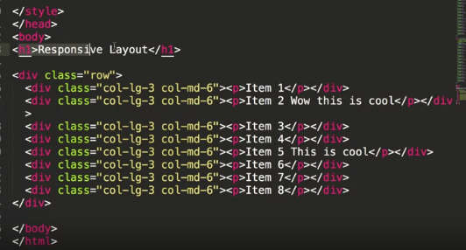

here we have one single row, and a single row contains eight divs, it can contain eight items, eight divs. Each one has paragraph that says item 1, 2, 3, 4 all the way to 8. And notice the classes that I'm assigning to each one. What I'm trying to tell the browser is that when it is a large device, I want only the classes with lg to apply. And it will happen automatically since the classes with md don't exist according to the browser, when the browsers larger in width then 1200 pixels. And since I know that floating elements just flow to the next line when they can't fit, I could very easily set up three, three, three, and continue to three. So that's right there at 12 columns but I could keep going because it's just going to flow to the next line. It's three, three, three, three again. So really I should have basically four of these things, right? Three, three and three, and three, that's four columns across, however, when the browser size, or the device size becomes smaller, and it becomes less than 1200 pixels, or 1199 pixels and lower, I want the layout to switch to these classes. And these classes are specifying that, they should really each item, each one of these things should take half the screen. So six columns plus six columns will take up the entire width of the screen. And again another couple of six columns will take the entire width of the screen and so on. So as I squeeze the browser and make it narrower, I should see that my four column lay-out, which is expressed in these threes, right? It's a little confusing, but it's 3 columns and there's 12 columns all together so you have 4 columns across. So my four column lay-out, as I squeeze the browser and make it narrower, should become a two column layout, because I'm now specifying in a smaller device size six and six instead of three, three, and three. Now when the browser size gets to less than 950 pixels, none of these classes will exist as far as the browser will concern. And what's going to happen then? Well our divs will no longer be floated because the floating is only defined inside the media queries which means they will behave just like regular block level elements and they will automatically stack one on top of the other. So as the devices get smaller and smaller, I should really have one column with each one of these items stacked one on top of the other. The truth be told, I could've specified that media query for that size of the device, but, in this case, it's just a demo, and I knew that the items will stack anyway, I just left it alone this way. Let's go ahead and take a look at what this looks like in the browser. Okay, so here's our three, three, three and three layout which gives us four items across and it's just spilling over to the next line and gives us another four items across again. And notice if I squeeze the browser, in fact what we're going to do is we're going to open Chrome Developer Tools. So as I squeeze in this corner right here, you'll see the pixel size of the view port. And as I start squeezing the browser you see it jumps to two. As it gets closer and closer to 1200, once it gets past 1200 pixels, it becomes now 6 and 6 column layout, which means that now we're taking up half the space of the entire width of the browser.

IMPORTANT

USE META TAG TO STOP FURTHER ZOOM OUT IN MOBILES.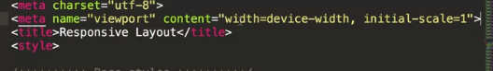

BOOTSTRAP:

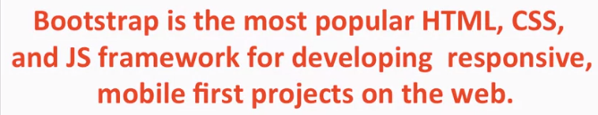

GitHub, which is basically a large website with code repository that has a social component to it, has over 90,000 stars or likes of the Bootstrap project. So it's the most popular project on the entire website. And it's been forked over 38,000 times.

Bootstrap consists mostly of CSS. It pre-defines a lot of CSS classes for you. So you know, a lot of the times, especially with a user interface that's a bit more complex than just a single HTML element or something, CSS needs to target a certain HTML structure. Well because of that reason, Bootstrap often times requires you to have a particular HTML structure in your HTML page.

CODE EXAMPLE:

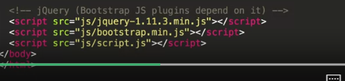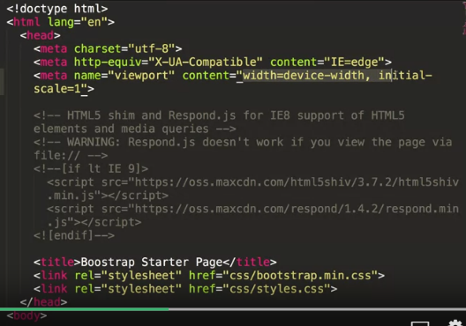

WHOLE CLASS:

one of the slides. But if we click on Getting started, the very first section here is Download, and we could choose a whole bunch of different options here, but the simplest one is to choose Bootstrap itself. It's already compiled from some sources and you can just click Download. When you download this and unzip it, inside that zip file, you'll have three folders, and the three folders will be css, fonts and js. And if you open up the css folder, you'll see that this is where the bootstrap.css is located, and bootstrap.min.css, it's just a different version of bootstrap.css. That is the minified version, meaning they removed all the spaces and extra things like that, that when you download it to your browser, those extra spaces and carriage returns wouldn't be downloaded because they don't really make any difference. Then there is the fonts folder and we're not going to talk about this right now, but it's definitely needed for basic Bootstrap functionality. And there's the js or JavaScript folder. And Bootstrap does have a JavaScript component, so you're definitely going to need this. And again, there's two different files, there's bootstrap.js and there's bootstrap.min.js. Now the min, again, is the minified version, spaces taken out, certain variables are renamed so they're not so long, and so on and so forth. Now you can also see here that I've downloaded a version of jQuery. Now the reason I did that is because bootstrap.js depends on jQuery. And in order to get this file, I would go to jQuery.com and let's go back to the front page, jQuery.com, and I'll click on this Download link.

Play video starting at :2:21 and follow transcript2:21

And you'll see that there's two different jQuery versions, there's 1.x and 2.x. Well, the difference between them is none. There is no difference. The only real difference is that the 2.x does not support 6, 7, or 8, Internet Explorer 6, 7, or 8. And for now, I think we're just going to go ahead and use jQuery 1.x. But I think in the future, as we keep moving along with the course, we will switch to the jQuery 2.x since the support for Internet Explorer is really kind of dying and Microsoft just recently announced they're basically not supporting anything in Internet Explorer, anything below version 11. So it makes sense just to move on from it, and the user base for those earlier versions is really, really small at this point.

Play video starting at :3:7 and follow transcript3:07

So if you download this right here and save that file to your js folder, it will end up being jQuery.1.11.3.min.js, and this is obviously as of this recording. Let's close that up and take a look at the main HTML page. Well, the beginning of it is nothing that you haven't seen before already. You've seen this already. And there's the heading tag, or the head tag I should say, declares to be utf-8. This tag, or this meta tag, you haven't seen, but this is something that Bootstrap recommends you do, and basically just tells some versions of Internet Explorer that they should go ahead and use the latest version, or the latest compatibility version, of its rendering engine. There's our familiar meta viewport tag, exactly the same as we had it in some of the previous lectures. And there's the HTML5 shim and Respond.js. And what basically this is is a way for Internet Explorer 8 to support HTML5 and media queries. Well, hopefully, this is going to be taken out soon as Internet Explorer 8 will become less and less relevant. Then we have the title tag and, finally, we have the two link tags. The first one is the bootstrap.min.css, that's the actual Bootstrap CSS framework, and the second one is styles.css and that's really our styles. If we take a look at the CSS styles, it's an empty file, we haven't really put any of our custom styles there yet. So, all we're doing right now is relying on the Bootstrap framework and we put the styles here already just so we have a placeholder for our styles in the future. Note that we declared our style after we declared the Bootstrap CSS styles. And the reason that is is because we're going to be customizing whatever Bootstrap gives us and, therefore, we want to be overriding what Bootstrap gives us, not having Bootstrap override what we are trying to style. Finally, we get to the body tag and at the very end of the body tag, right before we close it, we declare some JavaScript files or some JavaScript libraries that we're going to depend on. First of all, Bootstrap JavaScript depends on jQuery, and that means that we first have to declare jQuery and then we will declare and reference the bootstrap.js. And last, we reference our own JavaScript file, which is likely to be using either the jQuery or the Bootstrap JavaScript files. And again, if you go and actually take a look at that script.js, it's really just an empty file at this point. It's just a placeholder for our future script. Well, let's take a look at what this HTML file looks like in the browser.

Play video starting at :5:55 and follow transcript5:55

Well, it looks just like that. There's absolutely nothing here, and that makes sense since we really didn't put any content in. Let's go ahead and put some content in right now. Let's go just start with h1 and say Hello Coursera! We save that and we go back to our browser and we see Hello Coursera shows up and clearly something's different than you would expect before. The font family clearly is not the default one and the color is a little bit different as well. So it looks like some Bootstrap styling is being applied. Well, to verify that, let's go ahead and right-click on it and go to Inspect Element. And when we inspect element, let's take a look. Yes, indeed, there's some styles that are being applied from the bootstrap.css. Another important thing to take a look at is the console because if you misspell something or you reference the wrong JavaScript file or something like that, there would've been some errors showing up right here. And since I don't see any errors, looks like we're in good shape. So this is the basic and the base Bootstrap starter page that you could take and start coding your Bootstrap based web pages. So to summarize, we got introduced to the most popular project on GitHub, which is Bootstrap. And we got introduced to the concept of Mobile First, that is, the importance of planning for the mobile version of your website from the very beginning. And we went over the Barebones Bootstrap web page. We saw how to download and install the Bootstrap artifact files as well as jQuery that is needed for the Bootstrap JavaScript framework. And we tested out that our Bootstrap page actually works and contains no errors. Next, we're going to talk about one of the core topics when discussing the Bootstrap CSS framework, and that is the Bootstrap Grid System.

BOOTSTRAP GRID SYSTEM:

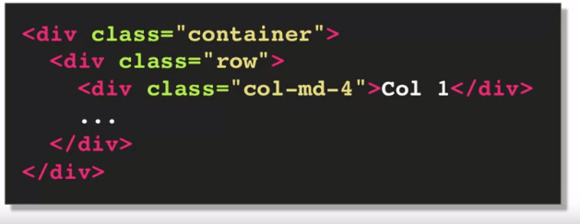

here's a quick snippet of HTML that's going to help us go through the different components of the grid system. So pretty much any Bootstrap grid layout is going to have these components as part of it. And, as I mentioned before, you could see that it does impose a bit of a structure into your HTML code but most of the time it would probably come up with this type of structure anyway. So let's go ahead and take a look as to what the structure is. First of all, your Bootstrap grid always has to be inside of a container wrapper. There are a couple of choices for that. One, you could use the container class or you could use the container fluid class.

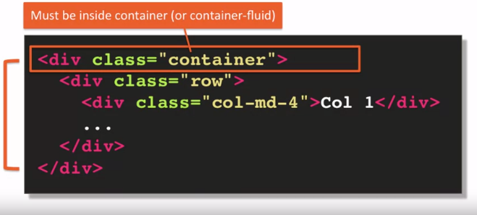

The container fluid class stretches your layout the full width of the browser and provides consistent padding around your grid and other content. There's other content that could go into the container, not just the grid. It's just that the grid requires that it should be inside a container wrapper. So that's container-fluid.

Regular container class has predetermined fixed width that is still responsive based on the width of the browser. In other words, it has certain width of one break point, a different width at a different break point and so on.

ROW ;

The next component of the grid is the row. So the row class creates horizontal groups of columns which means that the columns collapse and interact with each other as a group but independently from columns in another row. The row class also creates a negative margin, to counteract the padding that the container class sets up. Now why is that done? Well, each column already has its own padding because we want to visually separate columns from each other. If negative margin wasn't applied to the row, the padding of the container would then be in addition to the padding of the edge column. So the content of the column will no longer align nicely with the rest of the content outside of the grid. Now the Bootstrap documentation actually talks about this and explains it. But to be honest, I myself stared at it for a while before I finally understood what it's trying to say.

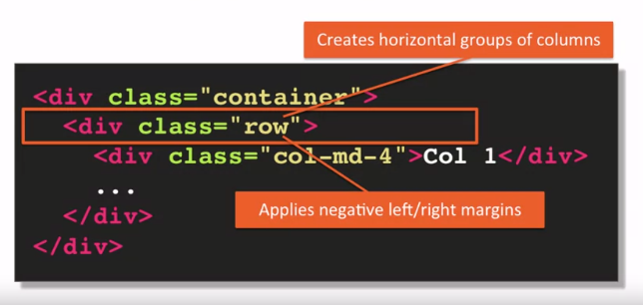

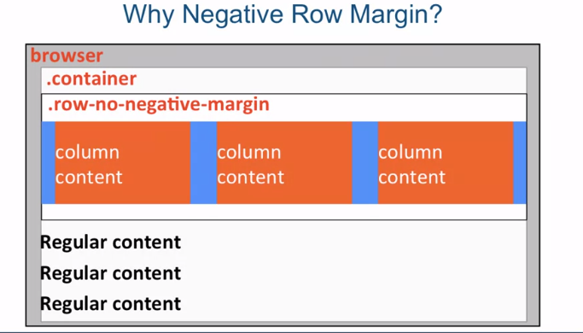

PROBLEM .ROW ALIGN WITJ REGULAR AND WE SEE GERY SPACE

IT SOLVE BY BOOTSTRAP

BOOTSTRAP GRID SYSTEM BASIC:

, for example, LG is defined as 1200 pixels and above. So minimum of 1,200 pixels. And what that means is that columns will collapse, in other words they'll stack one upon each other, below that width. So if the screen width is 1,200 pixels and above for, let's say a large size, it will go ahead and honor whatever you specify in this column-SIZE-SPAN. But if the screen width is below 1200 pixels this class will no longer apply. And basically what that will mean is that the columns in your row will collapse on each other, meaning they will stack one on top of the other. Which basically means that if you had several columns before, now you'll just have one column because everything is going to just stack one upon the other. And that is all unless there's another rule that applies. This is assuming there's no other rules that apply. So, for example, if for LG, large, you specified one column span and then for a medium size you specified another column span, well when you squeeze the browser and make the browser less wide and you cross that threshold of 1200 pixels, this, the large column span, will no longer apply. But if you have specified a md or medium, medium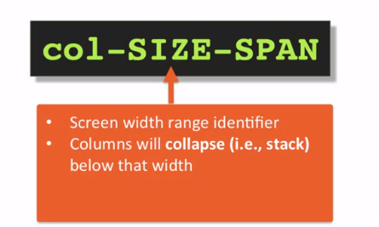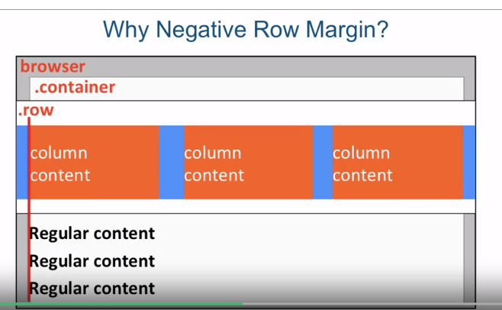 size of the screen, that then will kick in, and that will apply. And the span, is really, all it is is how many columns the element should span. So the values are from 1 to 12. And I've mentioned many times that Bootstrap is a 12 column grid layout. And what that means is the second the columns will adapt to 12, so if you specify let's say, 4, 4, and 4 then it will load up to 12. If you start specifying more than 12 columns within the row, well they'll do what other floats do, is that they will wrap to the next row. But it won't be a row within Bootstrap, it will just basically wrap itself automatically. So the point is, if you're specifying a whole bunch of columns, the element that pushes the total sum of the spans above 12 will automatically wrap to the next line. And this process can keep going every 12 columns. Lastly, there's nothing really magical about using DIVs as we did before in the example on the slide. You're free to use whatever makes sense to you in your design. In this example we're using the header and nav elements to define container and row components. In part two of this lecture we're going to jump into the editor and try some of these concepts out.

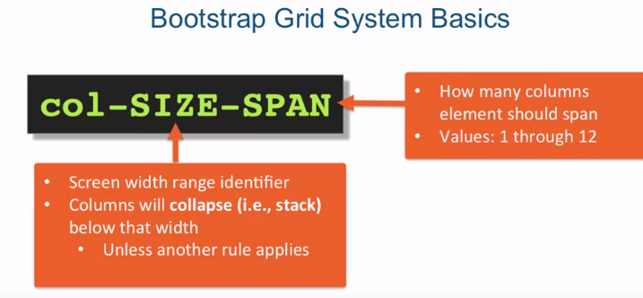

IMPORTANT:

HEADER AND NAV TAG IS USE IN THIS CODE TO DEFINE ROW.

CODE:

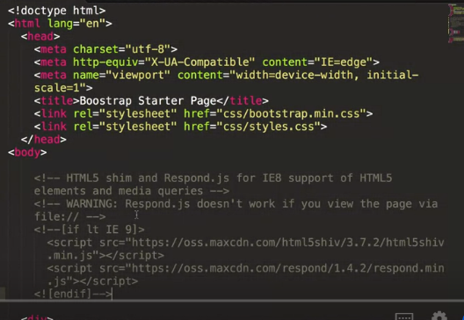

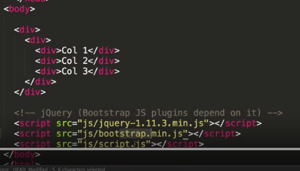

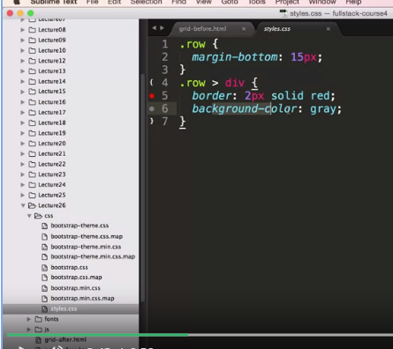

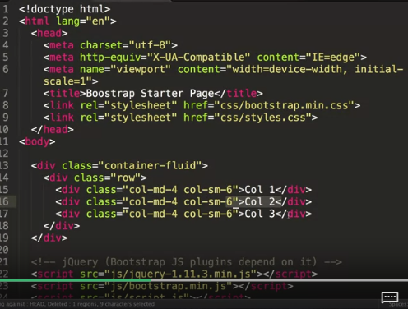

Col-md-4 and sm-6 is type of css grid style having some pixels default value set.

OUTPUT:

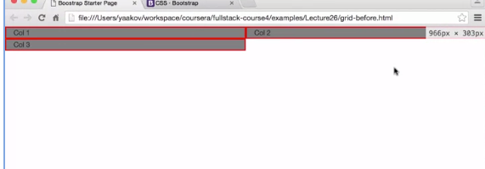

It is an input of sm-6 css grid layout base on 12 grid layout in short 6+6=12 so first row contain 2 column another 6 grid column is place blow

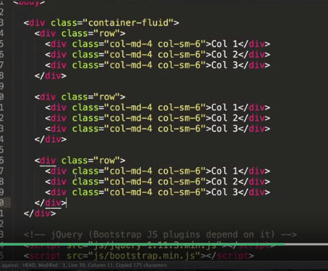

Output:

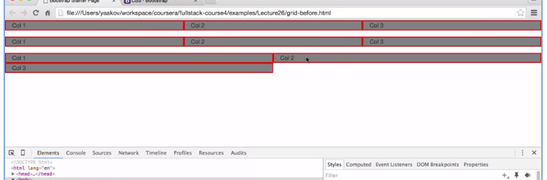

JAVASCRIPT:

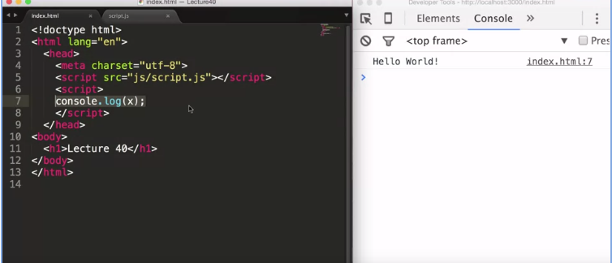

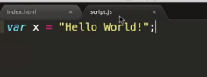

Code line by line and execute comlete after completion.

DEFINIG VARIABLS, FUNCTIONS AND SCOPE.

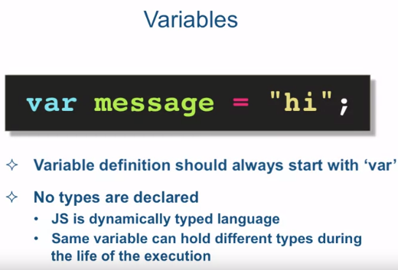

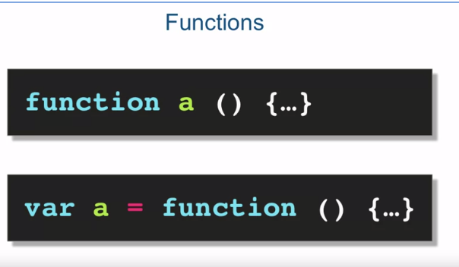

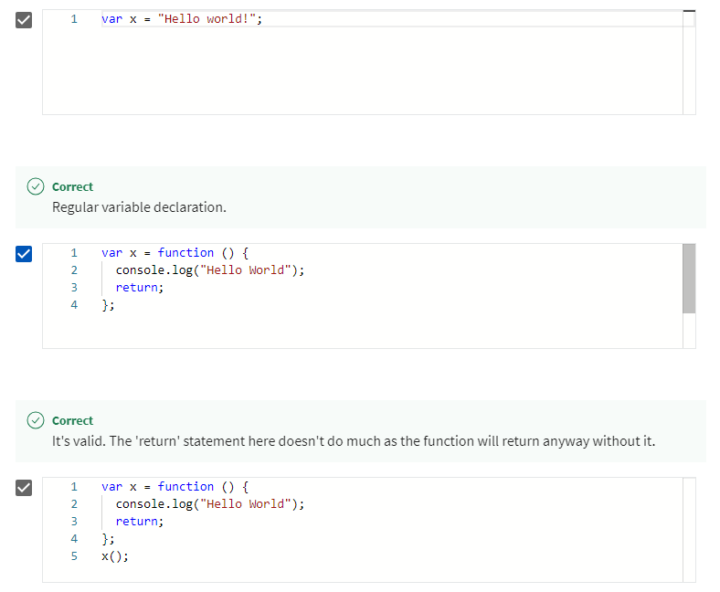

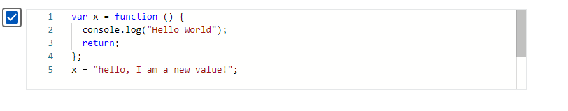

TYPE:

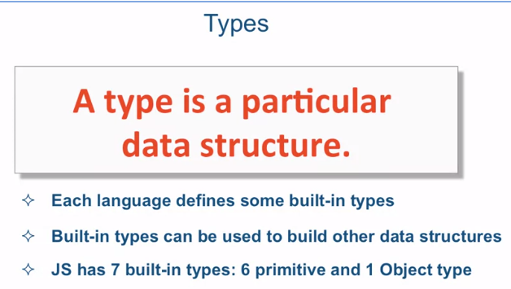

OBJECT TYPES:

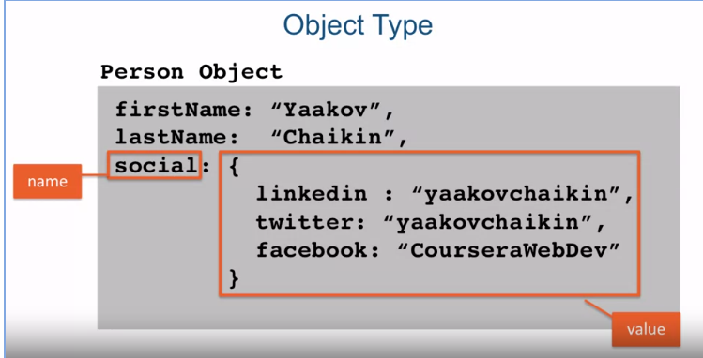

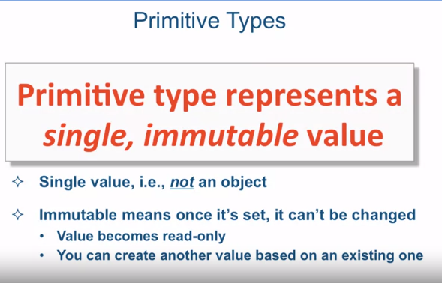

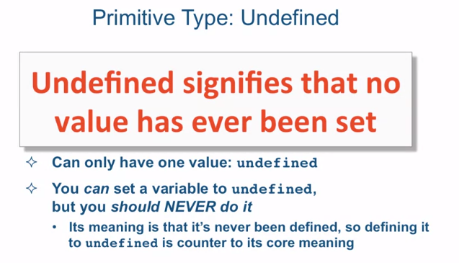

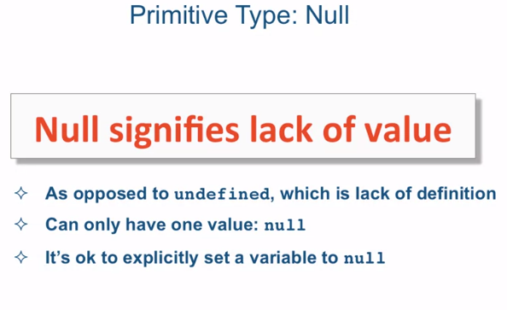

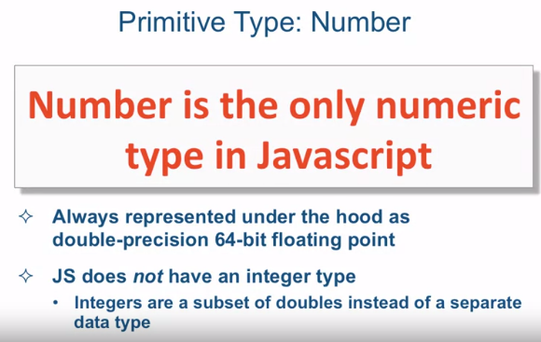

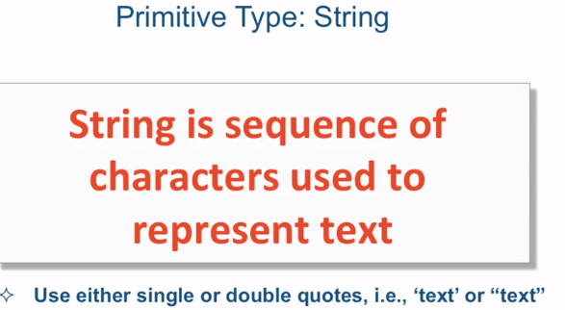

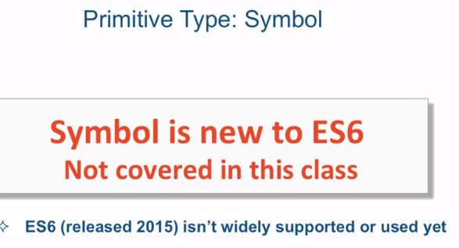

COMMON LANGUAGE CONSTRUCT:

STRING EXAMPLE:

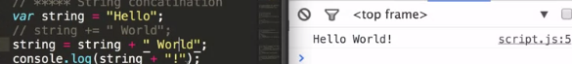

MATH OPERATOR:

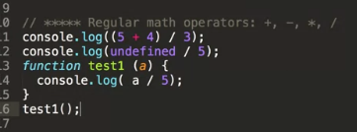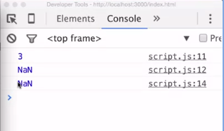

EQUALITY:

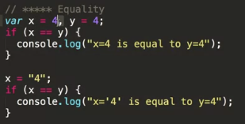

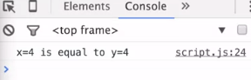

TYPE COVERSION:AUTOMATIC CONVERSION

FOOR LOOP:

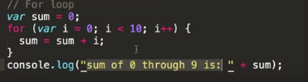

FUNCTION RETURN:

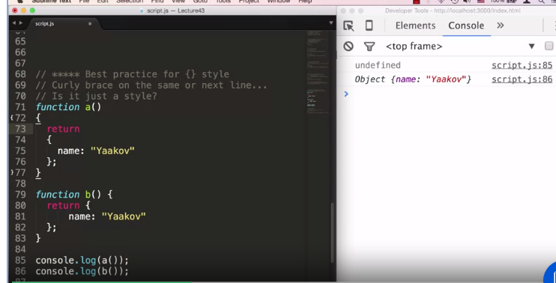

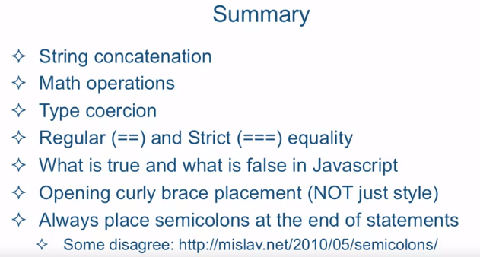

HANDLING DEFAULT VALUES:

OR OPERATOR:

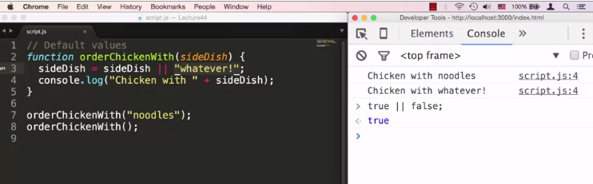

OBJECT TYPE DETAIL:

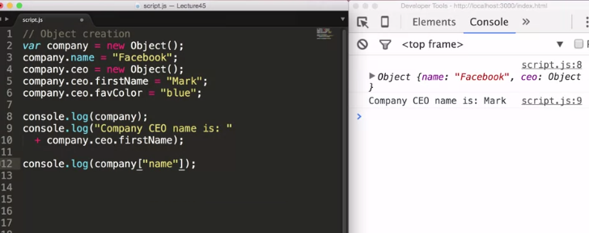

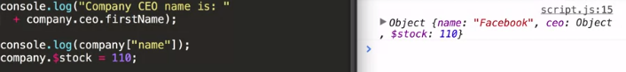

METHOD 1:

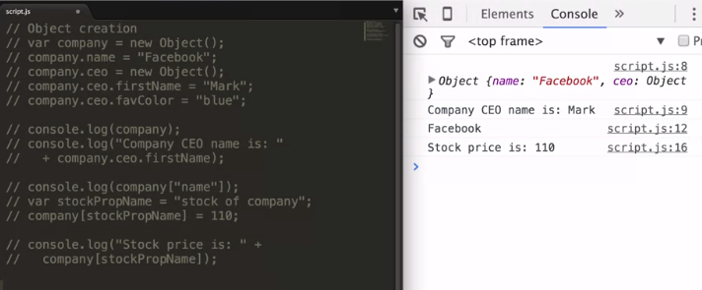

METHOD 2:

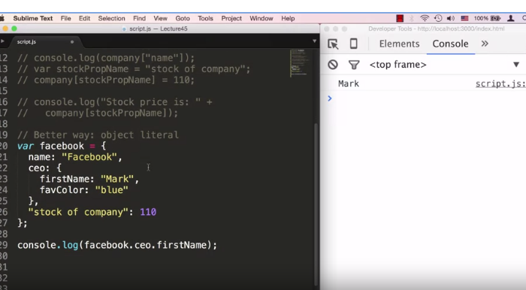

VALUE OF FUNCTION:

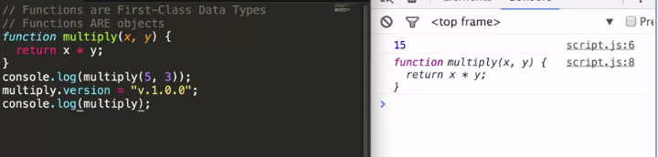

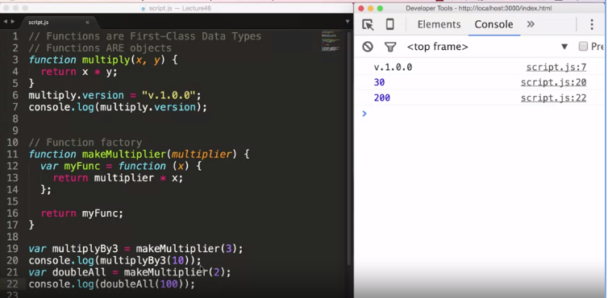Here multiply By3 represent myfun inside of makemultiplyer function.

Example 2

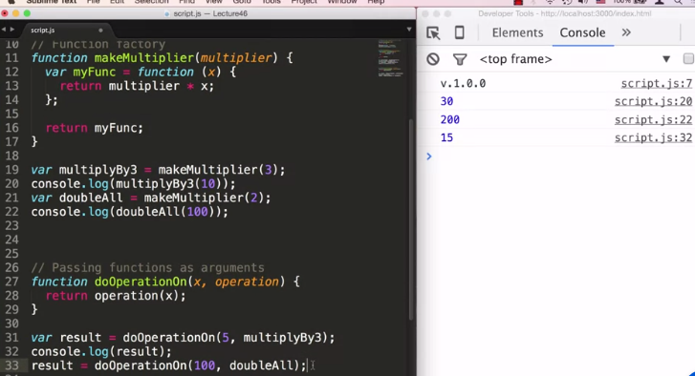funtions are first class datatype.

PASS BY REFERANCE:

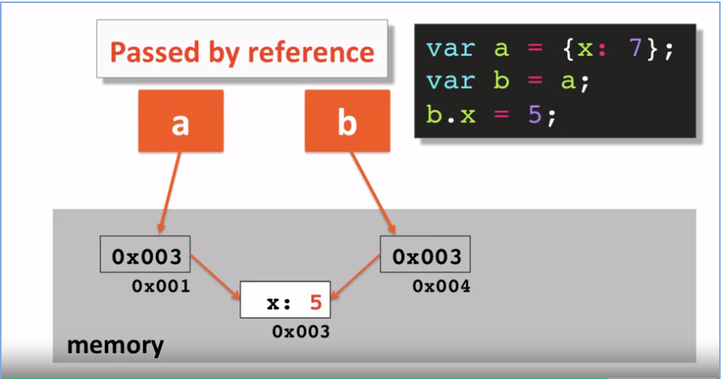

PASS BY VALUE:

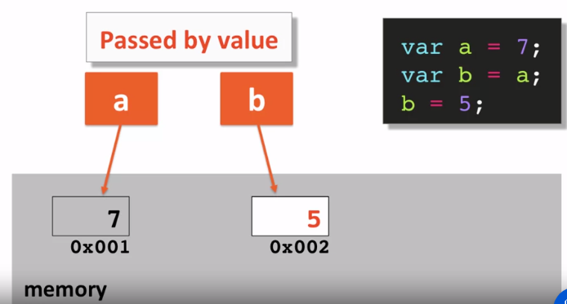

DOM MANIPULATION:

Use to access the document or the whole content of html file in java script.

In order to do this we need to put

<script src=”file path”></script>

In the last of body and also do this in script.js file

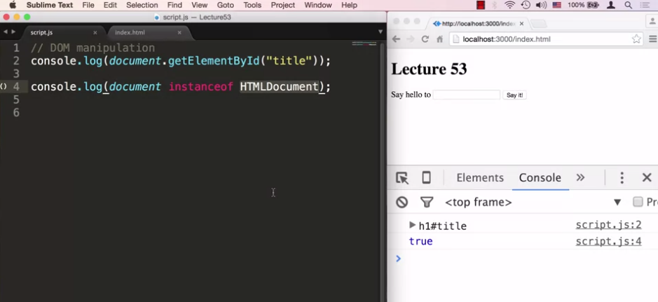

After this js file can access the html file.

Code snippt

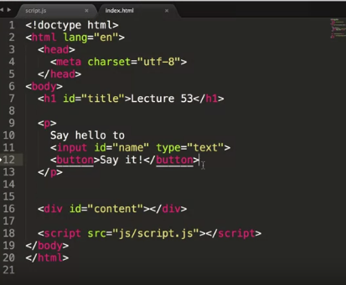

Example :

Value:to put value in search bar.

Innerhtml:to set html things.

textContent to put text in the web.

Queryallselector: to select evry thing exactly of same id or element.

This variable: point something.

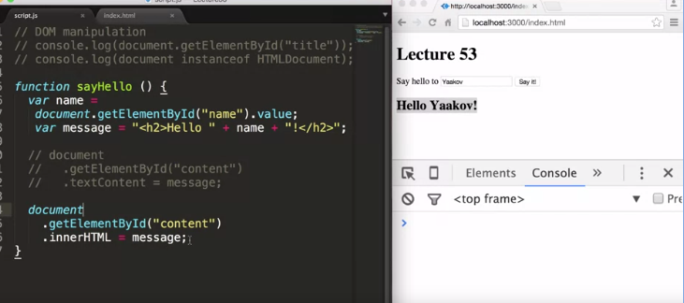

If we want to add title at specific point

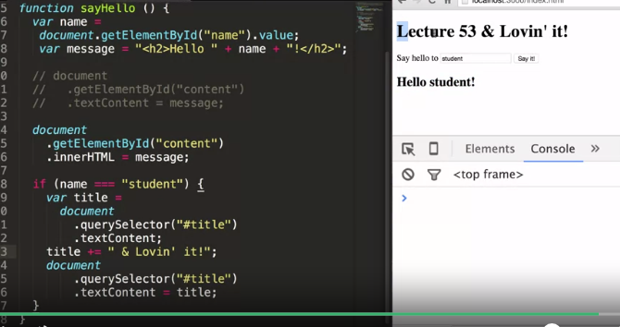

This variable example:

If we want to add title at specific point

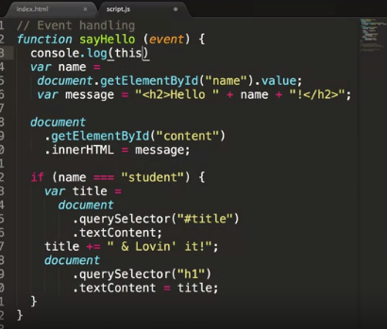

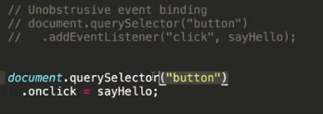

To execute whole functionality all at once put whole java or js file inside of it

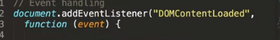

EVENT ARGUMENT:

HTTP:

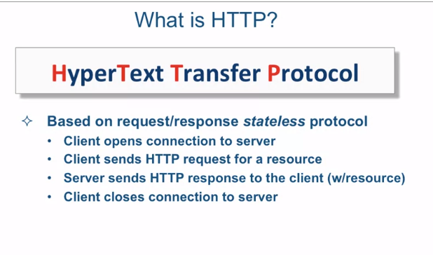

SOME UNIQUE TERMS:

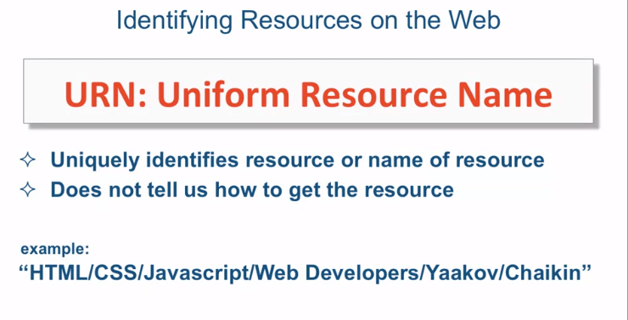

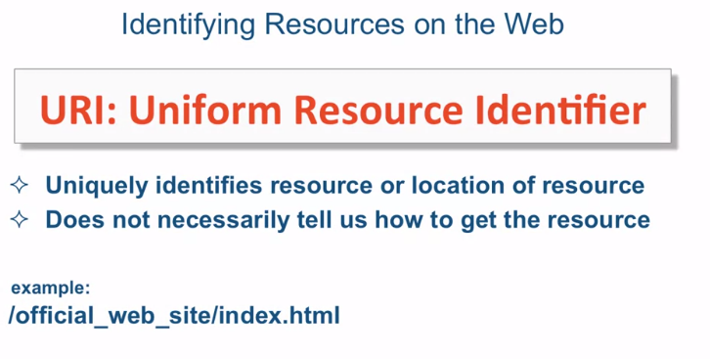

HTTP REQUEST STRUCTURE

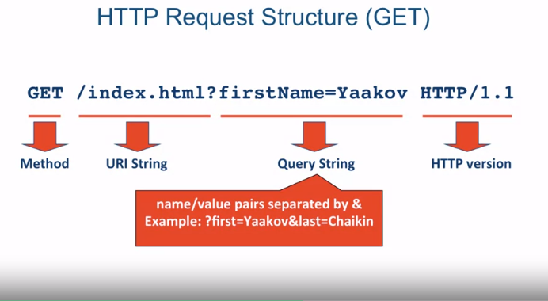

HTTP METHODS:

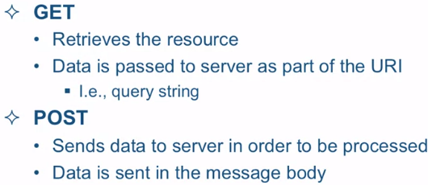

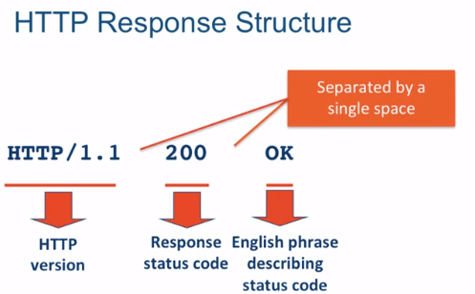

TYPICAL HTTP RESPONSE:

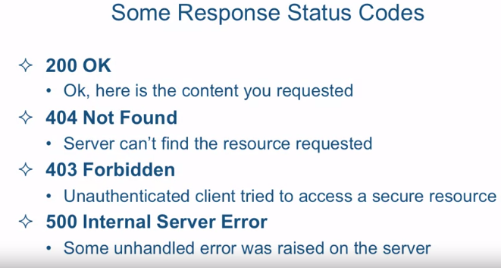

WHAT IS AJAX?

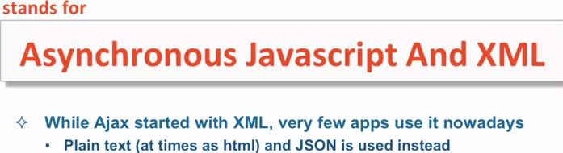

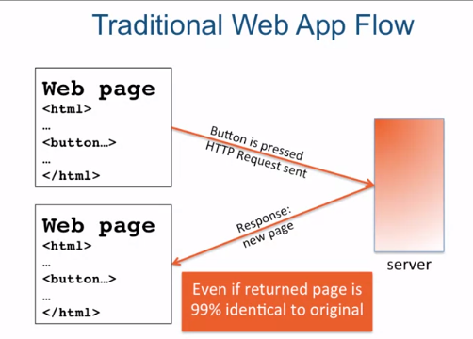

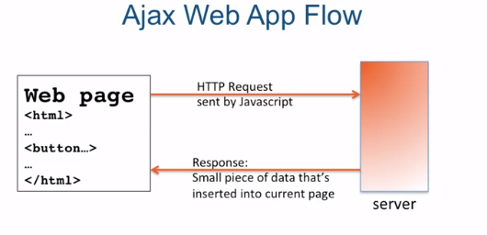

SYNCHRONOUS:

DOSRA KAM TAB TAK SHORO NAHI HOGA JAB TAK PEHLE NA MUKAMAL HO .

ASYCHRONOUS:

DONE MULTIPLE TASK AT A TIME.  
 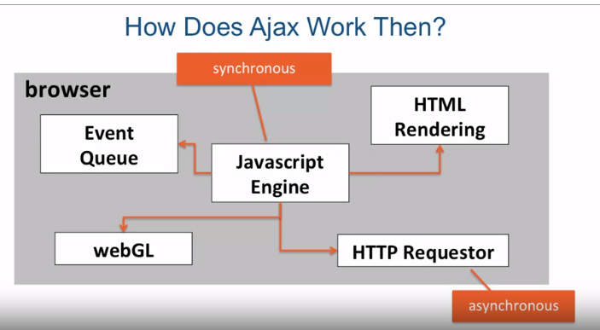

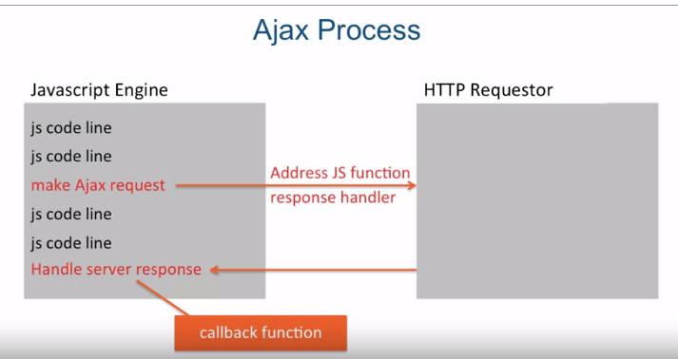

CODE EXAMPLE:

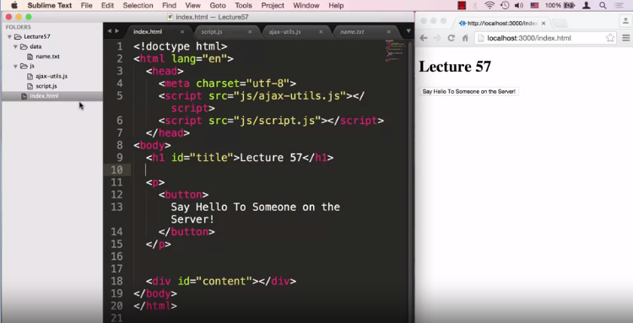

AJAX

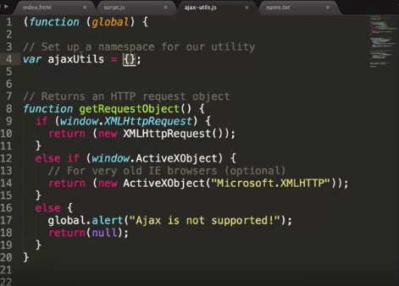

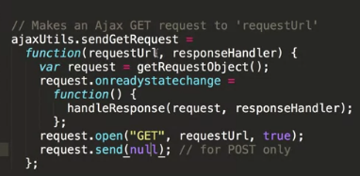

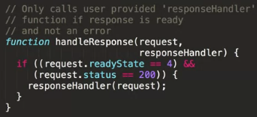

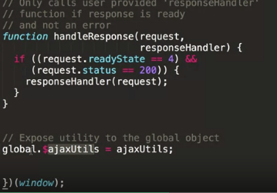

JAVA SCRIPT:

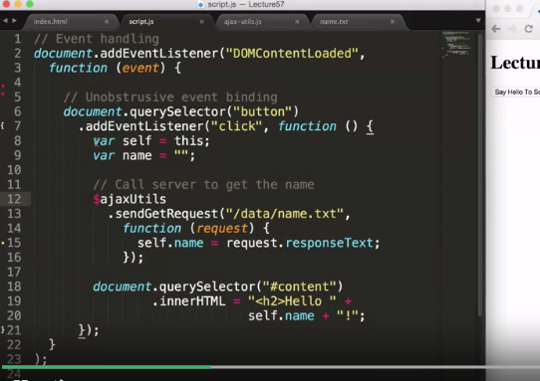WRONG

CORRECT

CORRECT:

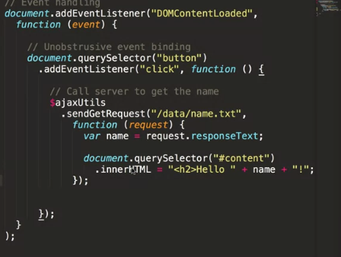

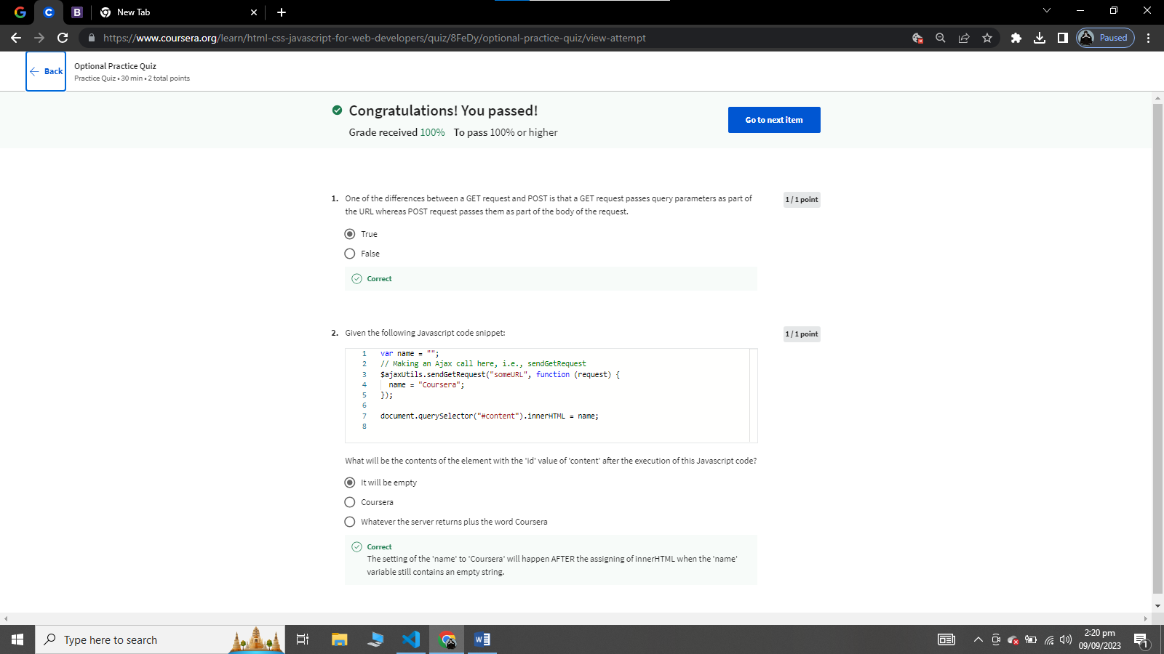

PROCESSING JASON:

USE TO SEND DATA BETWEEN SERVER AND CLINET.

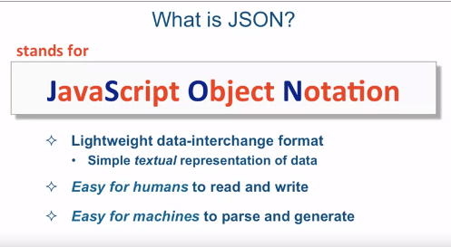

COMPLETELY INDEPENDENT:

RULES:

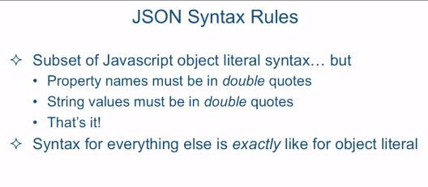

EXAMPLE

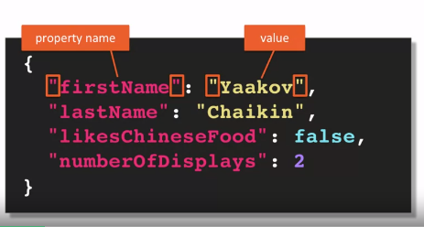

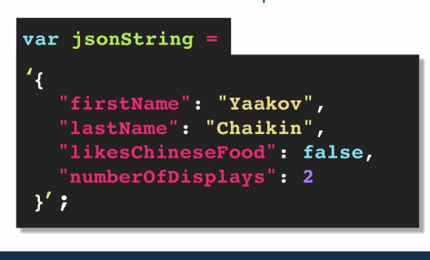

COMMON MISCONCEPTION:

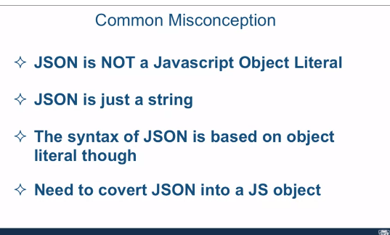

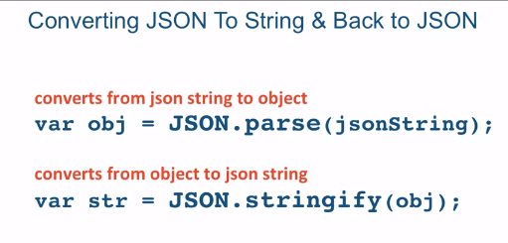

INSERT THIS PART IN AJAX FILE INSTEAD OF PREVIOUS ONE:

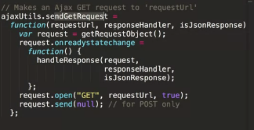

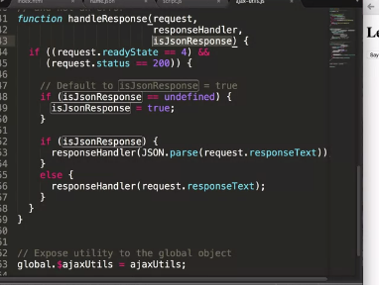

ADD THIS IN JS FILE

